**What is the basic structure of a C program?**

C program is divided into 7 parts. This 7 parts called the basic structure of C Programs. With this structure no one can do coding or programming in C. The importance of structure, you get in the answer.

1. Document section
2. Preprocessor/link Section
3. Definition section
4. Global declaration section
5. Function declaration section
6. Main function
7. User-defined function section

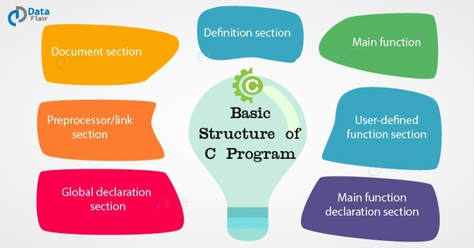

From the above C program, we can easily understand the location of each element in C Program.

1. Documentation section - Consists of comments lines which include the name of programmers, time and date. This section helps to give you an overview of the program.
2. Link section - Consists of header files and also provide a instruction to compiler to link functions from the system library.
3. Definition section - Contains all the symbolic constants (Marcos).
4. Global Declaration section - Those variables which can be used anywhere in the program.
5. main() function section - This section contains 2 parts, declaration and executable part.
6. Subprogram section - contains all the user functions, which are used to perform a specific task.

Documentation Section  
Link Section  
Definition Section  
Global Declaration Section  
main()  
{  
Declaration Section  
Executable part  
}  
Subprogram section  
Function 1  
Function 2  
.  
.  
function n

**The Documentation Section** consists of a set of comment lines giving the name of the program and other details.

**The Link Section** provides instructions to the compiler to link functions from the system library.

**The Definition Section** defines all symbolic constants.

**The Global Declaration Section:** There are some variables and those variables are declared in this section that is outside of all functions.

**main() function:** Every C program must have one main function section. This section contains two parts, declaration and executable part.  
**Declaration Part** declares all the variables used in the executable part.  
There should be at least one statement in the **executable part** which contains instructions to perform certain task.  
The declaration and executable part must appear between the opening and closing braces. All statements in the declaration part should end with the semicolon.

The **Subprogram Section** contains all the user defined functions that are called in the main function.

**Example Program:**

1. 1
2. 2
3. 3
4. 4
5. 5
6. 6
7. 7
8. 8
9. 9
10. 10
11. 11
12. 12
13. 13
14. 14
16. /*Documentation Section: program to find the area of circle*/
17. #include "stdio.h" /*link section*/
18. #include "conio.h" /*link section*/
19. #define PI 3.14 /*definition section*/
20. **float** area; /*global declaration section*/
21. **void** main()
22. {
23. **float** r; /*declaration part*/
24. printf("Enter the radius of the circle\n"); /*executable part starts here*/
25. scanf("%f",&r);
26. area=PI*r*r;
27. printf("Area of the circle=%f",area);
28. getch();
29. }

**Basic structure of C programming:**

To write a C program, we first create functions and then put them together. A C program may contain one or more sections. They are illustrated below.

The basic structure of C program is as follows:

**IN SHORT**:

1.DOCUMENTATION

2.LINK SECTION

3.DEFINITION SECTION

4.GLOBAL DECLARATION SECTION

5.MAIN FUNCTION SECTION

6.SUB PROGRAM SECTION

**IN DETAILS**

**1 . DOCUMENTATION->>**

The documentation section consists of a set of comment lines giving the name of the program, the author and other details, which the programmer would like to use later.

**2. Link section->>**

The link section provides instructions to the compiler to link functions from the system library such as using the [#include directive](http://www.onlineclassnotes.com/2015/04/what-is-include-directive.html?ref=Content+Body).

**3.Definition section:** The definition section defines all symbolic constants such using the [#define directive](http://www.onlineclassnotes.com/2015/04/what-is-define-directive.html?ref=Content+Body).

**4.Global declaration section:** There are some variables that are used in more than one function. Such variables are called global variables and are declared in the global declaration section that is outside of all the functions. This section also declares all the [user-defined functions](http://www.onlineclassnotes.com/2015/04/what-is-user-defined-functions.html?ref=Content+Body).

**5.main () function section:** Every C program must have one main function section. This section contains two parts; declaration part and executable part

**1. Declaration part:**The declaration part declares all the [variables](http://www.onlineclassnotes.com/2015/04/what-are-variables-what-are-conditions.html?ref=Content+Body) used in the executable part.

**2.Executable part:**There is at least one statement in the executable part.These two parts must appear between the opening and closing braces. The [program execution](http://www.onlineclassnotes.com/2015/04/what-are-variables-what-are-conditions.html?ref=Content+Body)begins at the opening brace and ends at the closing brace. The closing brace of the main function is the logical end of the program. All statements in the declaration and executable part end with a semicolon.

**6.Subprogram section:** If the program is a [multi-function program](http://www.onlineclassnotes.com/2015/04/what-is-multi-function-program.html?ref=Content+Body) then the subprogram section contains all the [user-defined functions](http://www.onlineclassnotes.com/2015/04/what-are-necessities-or-advantages-of.html?ref=Content+Body) that are called in the main () function. User-defined functions are generally placed immediately after the main () function, although they may appear in any order.

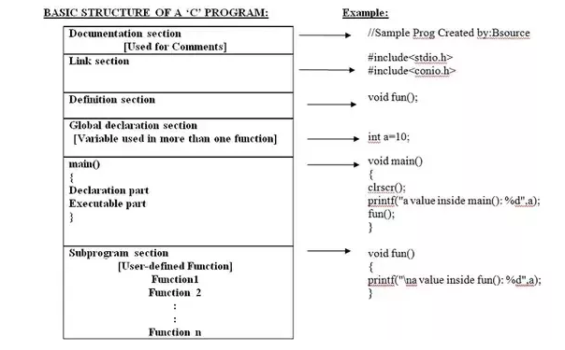

The basic structure of C program is as follows:

**IN SHORT**:

1.DOCUMENTATION

2.LINK SECTION

3.DEFINITION SECTION

4.GLOBAL DECLARATION SECTION

5.MAIN FUNCTION SECTION

6.SUB PROGRAM SECTION

**IN DETAILS**

**1 . DOCUMENTATION->>**

The documentation section consists of a set of comment lines giving the name of the program, the author and other details, which the programmer would like to use later.

**2. Link section->>**

The link section provides instructions to the compiler to link functions from the system library such as using the [#include directive](http://www.onlineclassnotes.com/2015/04/what-is-include-directive.html?ref=Content+Body).

**3.Definition section:** The definition section defines all symbolic constants such using the [#define directive](http://www.onlineclassnotes.com/2015/04/what-is-define-directive.html?ref=Content+Body).

**4.Global declaration section:** There are some variables that are used in more than one function. Such variables are called global variables and are declared in the global declaration section that is outside of all the functions. This section also declares all the [user-defined functions](http://www.onlineclassnotes.com/2015/04/what-is-user-defined-functions.html?ref=Content+Body).

**5.main () function section:** Every C program must have one main function section. This section contains two parts; declaration part and executable part

**1. Declaration part:**The declaration part declares all the [variables](http://www.onlineclassnotes.com/2015/04/what-are-variables-what-are-conditions.html?ref=Content+Body) used in the executable part.

**2.Executable part:**There is at least one statement in the executable part.These two parts must appear between the opening and closing braces. The [program execution](http://www.onlineclassnotes.com/2015/04/what-are-variables-what-are-conditions.html?ref=Content+Body)begins at the opening brace and ends at the closing brace. The closing brace of the main function is the logical end of the program. All statements in the declaration and executable part end with a semicolon.

**6.Subprogram section:** If the program is a [multi-function program](http://www.onlineclassnotes.com/2015/04/what-is-multi-function-program.html?ref=Content+Body) then the subprogram section contains all the [user-defined functions](http://www.onlineclassnotes.com/2015/04/what-are-necessities-or-advantages-of.html?ref=Content+Body) that are called in the main () function. User-defined functions are generally placed immediately after the main () function, although they may appear in any order.

**Header section** where we include all the header files.

**Main section** which is the starting point of a program execution.

1. **Documentation section**
2. **Link section**
3. **Definition section**
4. **Global Declaration Section**
5. **main () Function Section**
6. **Opening Parenthesis ({) - Closing Parenthesis (})**
7. **Declaration Part**
8. **Executable Part**
9. **Sub Program Section**

**Thus, any C program basically has 9 parts, although not all parts are required to be specified in all the programs. However, having a link section, main () Function, Opening and Closing Parenthesis and Executable Part in any C program is compulsory for a complete and running C program.**

([more](http://ui4you.com/basic-structure-of-c-program/))

3.5k views · [View 1 Upvoter](https://www.quora.com/What-is-the-basic-structure-of-a-C-program)

[](https://www.quora.com/profile/Christina-Mackenzie-14)

[Christina Mackenzie](https://www.quora.com/profile/Christina-Mackenzie-14)

[Answered Apr 22, 2019](https://www.quora.com/What-is-the-basic-structure-of-a-C-program/answer/Christina-Mackenzie-14) · Author has **189** answers and **8.2k** answer views

Documentation section

Link section

Definition section

Global declaration section

main()

{

Declaration part

Executable part

}

Sub program section

Function 1

Function 2

…………….

……………

Function n

* In documentation section may consists of comments.
* Link, provide instruction to the compiler to link function from the library function.
* Definition, it consists of symbolic constants.
* A global declaration, it consists of function declaration and global variables.
* main (), it is the main part of every C program must have a main() function which is the starting point of the program execution.
* Subprograms, User-defined functions.
* The basic structure of C program includes 6 sections.
* 1)Documentation Section.
* 2)Link Section.
* 3)Definition Section.
* 4)Global Declaration Section.
* 5) Main function Section.
* 6)Sub Program Section,
* For more Details